Leave
four
blank lines
before the title
PAPER TITLE IN 14-point FULL CAPS,
BOLD AND CENTERED
Leave two
blank lines
First Author¹ and Second Author²
One blank line
¹ Affiliation of first author and email address
² Affiliation of the second author
Leave three
blank lines
before the abstract
Abstract: The first section of the manuscript should be an abstract, where the aims, scope and conclusions of the papers are shortly outlined. A typical length would be between 150 and 300 words.
All the lines so far (title, authors, affiliation and abstract) are centred, indented left and right by 12 mm with respect to the remaining part of the manuscript.
One blank line
Keywords: Please include up to five keywords
Leave two blank
lines before the first section
TITLE OF FIRST SECTION
One blank line
Headings, format and style. Section headings should be in full caps, 12-points. Leave one blank line between the heading and the first line of the text. At the end of the section, leave two blank lines before the next section heading.

Between paragraphs, leave one blank line gap. The text should be right and left justified. The recommended font is Times New Roman, 11 points. All text must be single-spaced. Page design should be consistent throughout the paper.

Secondary headings
Secondary headings should be underlined; the text starts in the immediately following line. Leave one blank line before and after each secondary heading. Please, do not use more than two levels of headings, try to keep a simple scheme.

The paper must be written in the best possible technical and grammatical English. Titles should be concise and should describe the content of the paper. If you have a long title, please consider to shorten it at maximum 12 words. The required length of the paper is 7-12 pages (max. 15).

Papers need to be submitted in pdf format.

Headers and Footers. Please update the headers of the even pages and the footer on the first page with the author’s name(s). Also, include the paper title in the header on the odd pages, starting on p3.

Copyright. The International Committee on Aeronautical Fatigue and Structural Integrity (ICAF) advocates open-access to scientific data and, as of 2023, uses a Creative Commons license for publishing and distributing any papers. A Creative Commons license does not relinquish the author’s copyright; rather it allows them to share some of their rights with any member of the public under certain conditions whilst enjoying full legal protection. By submitting an article to ICAF, the authors agree to be bound by the associated terms and conditions including the following:
As the author, you retain the copyright to your Work. By submitting your Work, you are granting anybody the right to copy, distribute and transmit your Work and to adapt your Work with proper attribution under the terms of the Creative Commons Attribution 3.0 United States license. You assign rights to ICAF to publish and disseminate your Work through electronic and print media if it is accepted for publication.

It is noted that no paper can be included in the symposium proceedings unless the author has agreed to the terms in the Publishing Agreement (which can be found on the ICAF 2023 conference website) which has to be submitted with the final paper, after the paper has been reviewed and accepted.

If a figure, photograph, or table has been published previously, the author must obtain written approval from the original publisher.

Approvals. It is the author’s responsibility to obtain all necessary approvals from the author’s employer prior to submission of the paper. Once a paper has been uploaded, reviewed by the author, and officially submitted, it will not be possible anymore to edit the document.

Illustrations, tables and equations. Illustrations and tables should be numbered consecutively as they are presented (Figure 1, Figure 2, etc., and Table 1, Table 2, etc.). A descriptive caption, including figure number, should be placed directly below the illustration (see Figure 1). A descriptive legend, including table number, should be placed immediately above the table (see Table 1). Each figure and table should be mentioned or called out before it appears. More than one figure and/or table may appear on a page.

Table 1: Margin settings.
Margins | A4 (210 x 297 mm)
Top | 25 mm
Bottom | 25 mm
Left | 25 mm
Right | 25 mm

Tables and illustrations and their captions should be centred. All graphics should be understandable when printed in black and white. Make sure that the interpretation of graphs does not depend on colour. Use symbols or patterns on line and bar graphs to identify lines and columns.

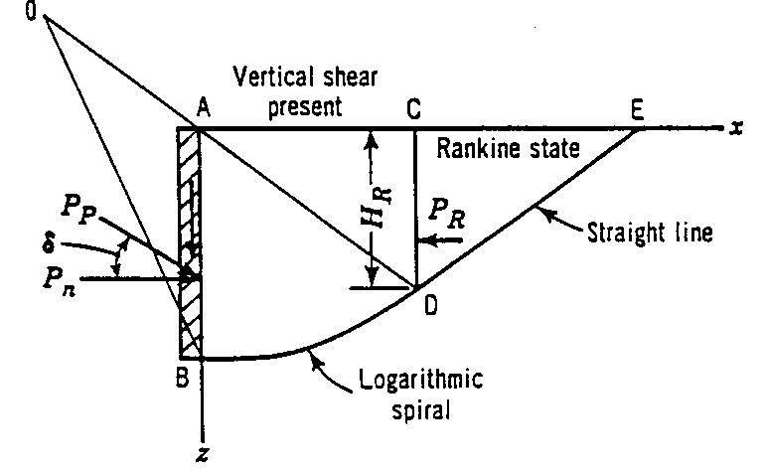
Figure 1: Sample line art illustration.

An equation should be preceded and followed by one blank line, and should be referred to, in the text, in the form Eqn. 1. All symbols should be explained within the manuscript.

(1)

Units. The International System of Units (SI) is to be used; other units can be used only after SI indications, and should be added in parenthesis.

References. In the text, the references should be a number within square brackets, e.g. [3], or [4–6] or [2, 3]. The references should be listed in numerical order at the end of the paper.

Journal references should include all the surnames of authors and their initials, year of publication in parenthesis, abbreviated title of the journal (in italic), volume number, issue number and pages.

References to books should include all authors surnames and initials, year of publication in parenthesis, the book title (in italic), the name of publisher and place of publication. Reference to multi-author works or proceedings should include, after the date of publication, “In:” followed by the book title, volume number (if any) and pages, name(s) of the editor(s), followed by (Ed.) or (Eds.), name of publisher and place of publication.

Examples:

REFERENCES

[1] Author1, A. and Author2, B. (2000), Eng. Fract. Mech., vol. 85, n. 6, p. 1234.
[2] Author3, C. (2001). In: Design for durability in the digital age, Proceedings of the 21st ICAF Symposium, vol. I, pp. 124–138, Rouchon, J. (Ed.), Cépaduès Editions, Toulouse.

